What is Good Food?
STEM Academy Community Project
“…how way leads onto way”

Your task: Develop your thinking about ONE of the STEM Academy Community Project essential questions: What is good food?
What it is: (and it’s a little bit different from the mapping you were doing last week)
- A visual representation of your thinking
- An illustration of your connections to a central idea or question
- Avenues of thinking; ideation; creative brainstorming
Directions:
- In the middle of your map, write the question: WHAT IS GOOD FOOD?

  - The rest of your mid map will SHOW your avenues of thinking about this central topic and idea.

REQUIREMENTS:
- One central question in the middle of your map: WHAT IS GOOD FOOD?
- 4 main branches of thought/ideas
- Plenty of sprouting ideas from your four main branches of thought (minimum of five for each branch)
- Several graphics and illustrations that support, organize, and unify your ideas
- Clear through lines to your central theme
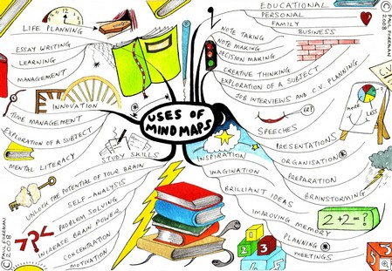
Approach:
You may choose to work individually or in groups of no more than 4.
ALL MEMBERS should be ACTIVELY INVOLVED in work.
Each group member should have pens or markers and CONTRIBUTE to mind map.

